Power Leveling

DESIGN DOCUMENT

By Aizin for the 2022 Pirate Software Game Jam

**Introduction** **2**

Description 2

Inspiration 2

Player Experience 2

Platform 3

Development Software 3

Genre 3

Target Audience 3

**Concept** **3**

Gameplay overview 3

Theme Interpretation (Sacrifice Is Strength) 4

Primary Mechanics 4

Secondary Mechanics 5

**Art** **6**

Theme Interpretation 6

Design 6

**Audio** **7**

Music 7

Sound Effects 7

**Game Experience** **7**

UI 7

Controls 7

**Development Timeline** **8**

## Introduction

aasdsa

### The System

**The Omniversal Toolkit**

I created a system for developing rpg system architectures, so I use this system for developing card games, ttrpgs, video games, and everything else

**Elements Academy; Origins TTRPG**

A TTRPG I created a method for dealing with the exchange of conditions and effects using conduits and verbs, which I designed to work in any medium

### The Setting

**The Planet Hematite**

Destroyed in a planetary collision, the remaining chunks orbit each other, allowing an atmosphere to form. Most citizens live in the city of progress, they travel back and forth using doorways that act as connecting portals.

**The Elements Academy**

The elements academy acts as the worlds greatest university, as it teaches how to use elemental powers, which are nigh omnipotent when mastered. The Elements Academy is Ran by Mal, who is Omniarch of Progress City.

### The Campaign

**Complete all 256 classes and Field Missions**

**Don’t abandon hope**

### The Inspiration

**Vampire Survivors**

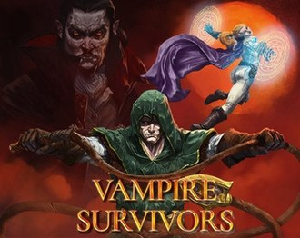Vampire Survivors is the main inspiration towards the game, adopting the roguelike template, an array of characters to unlock, 10 - 30 minute levels you need to battle your way through, and upgrades you can purchase to make you stronger.

**The Elders Scrolls; Morrowind**

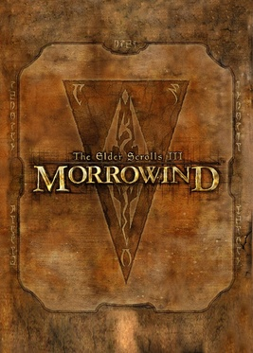Morrowind had a dice rolling system for determining success of failure, a spell creation system with many editable parameters, and a unique alchemy system with multiple parts you can gather to increase efficiency.

**Doki Doki Literature Club**

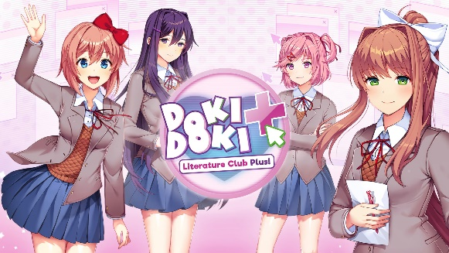Doki Doki Literature Club is a happy go lucky visual novel about school life before devolving into a dark and unsettling horror story. An NPC becomes self-aware, realizes they’re in a game, try breaking free from their predetermined path.

**Elements Academy Series**

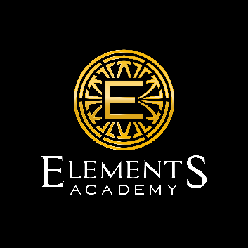Elements Academy is a school that teaches how to use the 16 elements and acts as a shadow government to nearly every country in the world. The academy is known for it’s cloning and organ harvesting programs that extended human life indefinitely, allowing academy students to heal or revive when met with tragedy.

### The Player Experience

### Game Types

First, traveling and interacting with the world in a top-down format, including crafting, training, initiating dialogue, and shopping.

Second, engaging dialogue with the visual novel format appears throughout the school, home, flashbacks, and during cutscenes

Third there is the survivor-like game, which is a top-down format with an experience bar, a power level counter, wave counter, gold counter, a

display for your 3 abilities, and a display for the possible alchemy buffs

### Platform

The game is developed to be released on windows PC

### Development Software

* Gamemaker Studio version 2.3 for programming
* Gimp for graphics and UI
* Fami Studio

### Genre

Singleplayer, rogue-like, visual-novel, rpg.

### Audience

The game is marketed toward casual game players, expecting the average player to fall off before completing due to its total length, while simultaneously leaving an array of options for hardcore players to continue consuming content for the foreseeable future. Fans of visual novels, roguelikes, and rpg maker style games will find joy in this

## The Concept

### Gameplay overview

The player controls a character who can only walk, interact, and perform 3 abilities. This restricted gameplay allows the game to play playable across all platforms, from web to mobile. Enter a

### Theme Interpretation (Shadow and Alchemy)

**Shadow interpretation – The elements academy is a secret organization that’s a shadow government of every country it resides. Within the academy you can learn shadow element magic, which allows you to blind enemies, harm the living, and heal the undead.**

Elements academy is a university for the elementally gifted, bringing species and countries from around the solar system to attend class. Go out and perform field missions between classes, with a free revival program to guarantee your overall safety there’s no reason not to.

***The missions may not be exactly what they seem.***

**Alchemy interpretation – In the Elements Academy alchemy class you gather ingredients and make potions to gain passive buffs in maps. There is are three Ability level systems and a Character level system, each has their own skill tree, allowing you to change all parameters.**

With alchemy I went literal and abstract, allowing you to literally perform alchemy with plants, metals, and alchemical equipment to create items and potions that temporarily improves your character. Alchemy also exists in the modular creation systems I made.

***The ability to modularly disassemble and reassemble are the cornerstones of alchemy within the plane of existence.***

### Primary Mechanics

| **Mechanic** | **Mockup** |
| --- | --- |
| **Visual-Novel** a  Initiates during cutscenes and dialogue, this even includes when you level up, as whatever the leader of your element will appear (Mal, Aura, or Frankie) |  |
| **Top-Down** a  When exploring the world or fighting you will be in a top down angled perspective. You can move with arrow, clicking, virtual joystick, using a controller, or entering wasd with a keyboard. |  |
| **Survivor-Like** a  The abilities and power levels are based on vampire survivors system, including the character unlock screen and the upgrade system, however our upgrade system can also target individual abilities, not just provide generalized buffs |  |
| **Fantasy-RPG** a  It takes place in a fantasy world with an array of races and environments.  Learn magic, fight magical creatures, befriend demi humans, and spend your schools days trying to stay above water. |  |

### Secondary Mechanics

| **Mechanic** | **Mockup** |
| --- | --- |
| **Friendships** a  A |  |
| **Day Night Cycle** a  Each day you have a limited amount of |  |
| **Merchant** a  The |  |
| **Alchemy** a  If a |  |

## Art

All art is hand made and designed to scale to a larger size while maintaining their quality, that way abilities that have their size increased wont look pixelated or out of place.

### Character Selection

There are 6 obtainable characters in this version of the game. If the game is successful, I will made 26 more characters and include a character creation system. Each character has their own unique starting ability, and they have their own positive/negative stat values based on what race and spawn rng they got.

### Ability Selection

You have three abilities your character can use. Each character has 1 unchangeable starting ability, and 2 you can choose. From the 2 you can choose, select from the 3 elements, 6 ability types, 6 query types, 4 target types, 6 relativity types, and 4 spawn types. If you don’t want to make your own ability, simply pick a trainer in game to get a class

### Alchemy Selection

When entering a map, you will be shown a UI with three flask symbols, which will prompt you to click and select from your collection of owned potions to use as a passive bonus for the map. Each flask can hold one potion, and you may not use the same potion more than once. Potions of the same type will not stack or be drinkable until worn off.

### Map Selection

For every 15 submaps, there is 1 over map. For every 256 maps including submaps, there’s a dungeon, tower, labyrinth, maze, and raid, spread somewhere between the 1st and 256th map. Every over map you complete unlocks another over map. Each map complete grants a character level, which is permanent. (power levels reset each map)

## Audio

### Music

Music will primarily be made using a recorded electric guitar, played by me, and will contain NES and electronic inspired music made with anvil and fami. I may make use of some songs I already have made, however that hasn’t been decided upon yet.

### Themes

Each character will have its own theme. Themes are played when a character enters a scene, makes a sudden declaration, or otherwise has the attention of the scene turned to them in some way. Themes will help players identify regions and characters due to the low resolution of the game when in the top down format.

### Ambient Noise

Every region will have its own unique ambient noise with different animals and music in the background. There will only be a couple of regions available in the demo. Ambient noises are designed to match their region, meaning a beach will have the sound of waves, birds, splashing, wind, and wildlife, while the city would have cars and dogs.

### SFX

SFX are the result of an action being performed, an effect being generated, or a condition being met. There is a collision sfx for each material in the game for example, that way when players miss an attack or it otherwise strikes an object of that material type, the sfx can play in the location to signify the collision has occurred.

## Game Experience

### UI

The first UI is for health and mana, which is set up diablo style.

The second UI is for your 3 abilities, showing their cooldown time and what power level they currently reside at.

The third UI is your abilities, passives, experience, and level bar, which are all at the top of the screen, with experience and level in the middle.

### Controls

**Keyboard**

Arrow keys / WASD  
**Gamepad**

Dpad

**Mouse**

Virtual Buttons and Joystick

**Touchscreen**

Virtual Buttons and Joystick

## Development Timeline

**MINIMUM VIABLE PRODUCT**

| **#** | **Assignment** | **Type** | **Status** | **Finish By** | **Notes** |
| --- | --- | --- | --- | --- | --- |
| 1 | Follow Survivor Tutorial | Coding |  | 7/19/24 | Youtube |
| 2 | Follow Orbit Tutorial | Coding |  | 7/19/24 | Youtube |
| 3 | Add Persistent/AOE | Coding |  | 7/19/24 | Youtube |
| 4 | Select Characters | Draw/Code |  | 7/20/24 | UI and sprites |
| 5 | Create Dialogue System | Database |  | 7/20/24 | Map it out |
| 6 | Create AI | AI |  | 7/21/24 | Give AI Abilities |
| 7 | Create 3 levels 1 tower | Level Design |  | 7/22/24 | 45 sublevel and 3 reg |
| 8 | Settings and Menus | UI and Code |  | 7/23/24 | UI and commands |
| 9 | Create Ingredients | Draw/Code |  | 7/24/24 | 16 types + 16 rocks |
| 10 | Create Alchemy | Draw/Code |  | 7/24/24 | UI and Potions |
| 11 | Create Quest System | Code/Draw |  | 7/25/24 | Character quests |
| 12 | Create VN Scenes | Draw/Code |  | 7/26/24 | Code |
| 13 | Create Skill Trees (4) | Draw/Code |  | 7/27/24 | Four 10x6 buttons |
| 14 | Create Ability Creation UI | Draw/Code |  | 7/27/24 | Selection boxes |
| 15 | Create Save System | Coding |  | 7/28/24 | Save files |
| 16 | Create Music for game | Music |  | 7/29/24 | Anvil and fami |
| 17 | Polish | ALL |  | 7/30/24 | Touch up anything |
| 18 | SUBMIT | Winning |  | 7/31/24 | Kneel before your god |

**MAXIMUM VIABLE PRODUCT**

| **#** | **Assignment** | **Type** | **Status** | **Notes** |
| --- | --- | --- | --- | --- |
| 1 | Extra Levels |  |  |  |
| 2 | Extra Element Types |  |  |  |
| 3 | Extra Ability Types |  |  |  |
| 4 | Character Creation |  |  |  |
| 5 | Raid |  |  |  |
| 6 | Dungeon |  |  |  |
| 7 | Maze |  |  |  |
| 8 | Labyrinth |  |  |  |
| 9 | Tower |  |  |  |
| 10 | Cave |  |  |  |
| 11 | Fortress |  |  |  |
| 12 | Castle |  |  |  |
| 13 | Village |  |  |  |
| 14 | Stronghold |  |  |  |
| 15 | Catacomb |  |  |  |
| 16 | Arena |  |  |  |
| 17 | Forest |  |  |  |
| 18 | Extra Characters |  |  |  |
| 19 | Extra Potions |  |  |  |
| 20 | Mobile |  |  |  |